**Steps need to follow while creating Connector and Topic** :

**Connector Creation**:

Step 1: Go to Git location for the particular connector and copy the .json file name.

Ex: **UserProfileEXACOnnector**

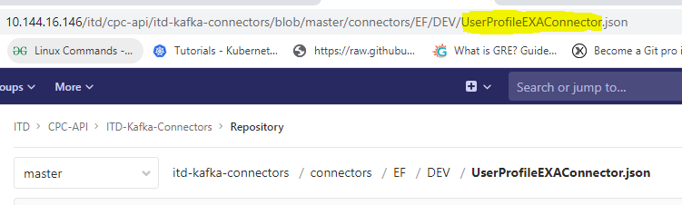

Step 2: Go to IDP and trigger Kafka_Connector_Ops.



Step 3: While triggering give value as below (select Build only):

* If connector needs to create, select create; if update, select update; if delete ,select delete in action field.
* The same way give required env name in env field.
* In file_name ,provide .json file name(copied from git)
* Build slave must be Test_Slave_Kafka.

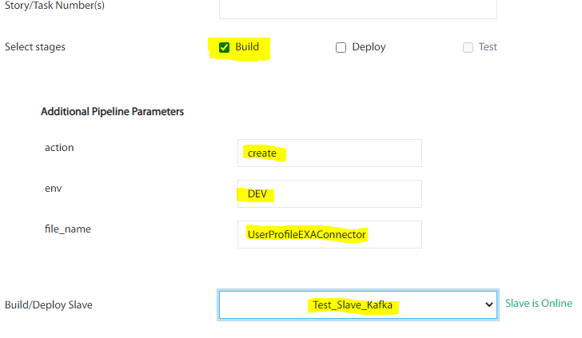

Step 4: After successful deployment in IDP, Goto env based connector nodes via superputty and check the status of deployed connector.(Below ip and port no is for dev)

curl <http://10.144.16.37:5450/connectors/dshbd-user-profile-exa-connect/status>

Note: (dshbd-user-profile-eri-connect )must be the connector name.

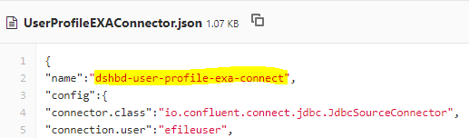

The same we can deploy connectors in different environments.

To restart connector use below command:

curl -X POST <http://10.144.16.37:5450/connectors/rp_di_efile_low_priority_connector/restart>

To resume connector use below command:

curl -X PUT <http://10.144.16.38:5450/connectors/rp_di_efile_high_priority_connector/resume>

Port Number in Dev Env :5450

Port Number in other all Env: 8083

**Topic Creation**:

Step 1: Goto git location for that particular topic name and make sure that replication-factor and partitions are there.

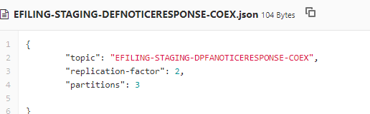

Step 2. Go to IDP and trigger Dev_topic_deployment. (in IDP different Pipelines are there for different env.)



Step 3: While triggering ,provide below date:

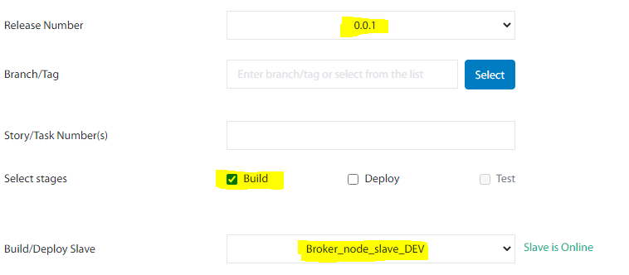

Step 4: In the build log search that particular topic and check whether it is successfully created.



* Kafka-Nodes excel sheet is attached in this mail.